Chapter 5, Solution 69.

In this case, the first stage is a summer

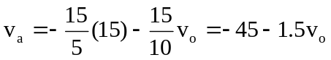

For the second stage,

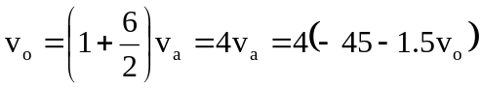
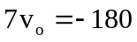 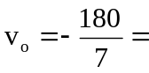 –25.71 mV.

